October 1st, 2017
Hi Church Family!

It’s officially autumn, and things are in full swing here at St. Columba’s. I am loving getting to know the patterns of my new home. It is a blessing to be fully moved into Priory Street, and Emily, Katherine, and I really appreciate all of you who helped us get settled! Please consider yourselves welcome guests anytime.

One joyful part of my week is attending coffee mornings on Tuesdays, because I enjoy having time to chat with all of you informally and to worship together in a relaxed setting. We’re hoping to continue to use this as an opportunity to invite the community into our church.

In addition to the launch of this new version of coffee mornings, this month was the autumn kick-off to many groups that were on holiday this summer. We had our first Community Lunch of the season on September 29th, and we will have the next one on October 27th. Please spread the word and invite your friends! The Elders commenced their meetings, as did Churches Together group, the Synod, and various other groups that use the church.

The Besom, The Island, and the Street Angels are back in full swing as well. Becky Lewis has taken over for Rob as director of The Besom, while The Island is continuing to grow their mentoring services. They are looking for male mentors to work with their Boys’ Club and one-to-one mentorship programs. The Street Angels began their outreach again in late September and are looking to fill their October rota. Please pray for our mission partners and if you have any donations (time, gifts, or things) please feel free to reach out to them.

As part of my work, my hope for the coming weeks is to meet with all of you for an informal chat on your thoughts about the strengths of our church and your ideas for my time with you. Please email me at kaitlyngolden1@gmail.com or find me at church if you’d like to meet.

I pray that we all continue to accompany one another and serve each other and God joyfully.

Peace be with you!
Katie

October Calendar

Sun 1st Harvest Festival Service 10.15 am
Student Night 6.30 pm

Tues 2nd Coffee 10.30 am, Worship 12.00 pm

Sun 8th No morning service
Taize Service with Meal 4.30 pm

Tues 10th Coffee 10.30 am, Worship 12.00 pm

Weds 11th Elders’ Meeting 7.30pm

Sun 15th All Age Service
Student Night 6.30 pm

Tues 17th Coffee 10.30 am, Worship 12.00 pm

Sun 22nd St. Columba’s Worship 10.15 am
Student Night

Tues 24th Coffee Morning, 10.30am, Worship 12.00 pm

Fri 27th Community Lunch 12.15 pm

Sun 29th Lutheran Vespers at 4.30 pm

Tues 31st Coffee 10.30 am, Worship 12.00 pm

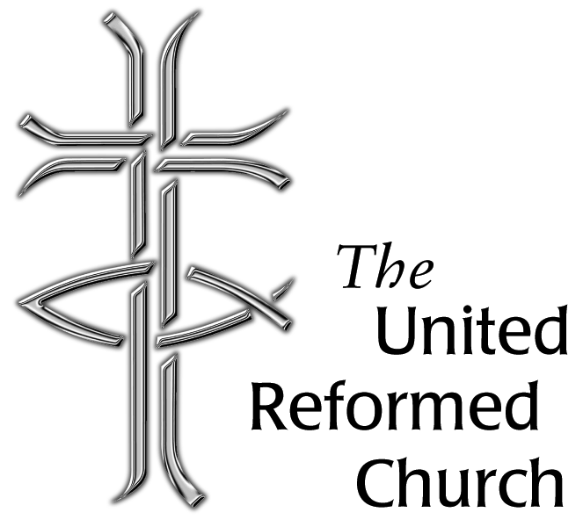

Minister: Rev’d Alison Micklem
tel: 01904 488291
e-mail: micklem@clara.co.uk

Secretary: Derek Thomson
tel: 01904 629905
e-mail: JDthomson@btinternet.com

Room Hire: Jim Robertson
tel: 01904 489201
e-mail: jasrobertson@talktalk.net

Please pray for:

- Students as they start at or return to the universities;
- Those of our fellowship who struggle with health issues
- Our Mission Partners in the Community Foundation
- The families across York who struggle to make ends meet
- Homeless people across York and the wider area
- The nationwide Besom conference on October 28th
- The various groups which use our building
- The Elders and all their work
- Our sister churches in East Yorkshire Mission & Care Group
- The Synod Council
- The Churches Together Group
- All those affected by political, economic, and climate crises

St Columba’s URC York
October 2017 Newsletter

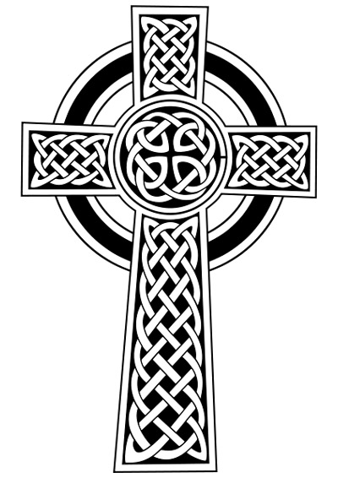

October 2017

